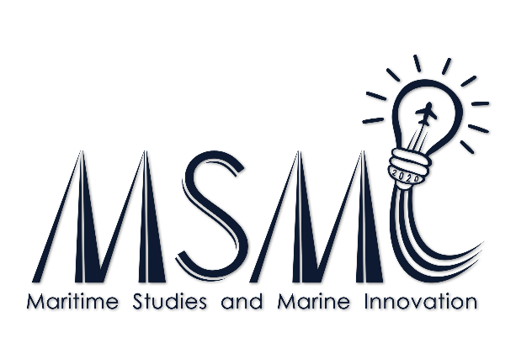

Title of the Paper (Times New Roman, Bold, 14pt, Center)
Author¹, Author² (Times New Roman, 12pt, Center)
¹First author’s affiliation, Address, City, Postcode and Country (Times New Roman, 10pt, Italic, Center)
²second author’s affiliations, Address, City, Postcode and Country (Single space)
*Corresponding author’s. email: xxx@xxx.xx.xx

Abstract
The abstract must be written in English (American spelling and usage) and should not exceed 250 words (3-5 keywords). The abstract should include the title of the paper, name of the author/ authors and their affiliation, contact details with the name of the presenting author underlined. The abstract must be prepared in a single paragraph with single line spacing, typed in Times New Roman, 12 points (bold for the title) with a margin of 3 cm in A4 paper size. All abstracts should be submitted as attachments, in MS Word format by online submission via the conference website at http://www.maritime.cmu.ac.th/MSMI2020. The instructions for oral & poster presentation and template format for full paper submission can be downloaded from MSMI2020 website.
Keywords: 3-5 words (Times New Roman, 12pt)

